**White to play and win!**

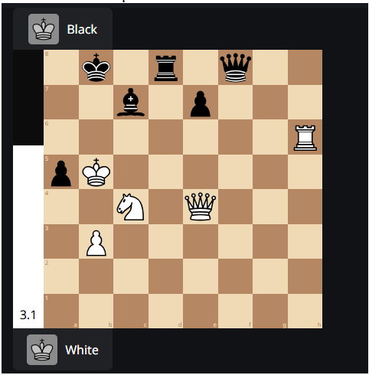

INSTRUCTIONS

* Create a customized game on chess.com or your favorite chess app.
* Start playing with white while making strong/best moves for black.
* Copy the PGN file of your game and paste it in PGN section below for analysis.
* Save this document with your name in pdf format and send it to rushhourchess@gmail.com

**Fill in the details below**

Your Name:

Your Country:

**PGN:**

[Site "Chess.com"]

[Result "*"]

[SetUp "1"]

[FEN "1k1r1q2/2b1p3/7R/pK6/2N1Q3/1P6/8/8 w - - 0 1"]

1. Rb6+ Bxb6 2. Ka6 Rd7 3. Qa8+ Kxa8 4. Nxb6+ Kb8 5. Nxd7+ Kc8 6. Nxf8 *